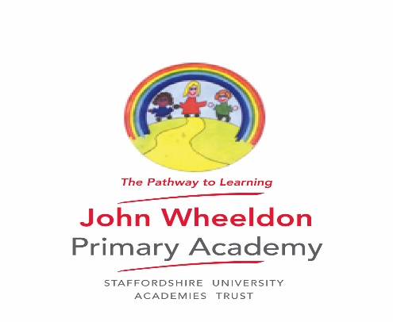

JWPA

Accessibility Plan 2016-17

This Accessibility Policy and Plan are drawn up in compliance with current legislation and requirements as specified in Schedule 10, relating to Disability, of the Equality Act 2010. The Local Academy Council are accountable for ensuring the implementation, review and reporting on progress of the Accessibility Plan over a prescribed period.

John Wheeldon Primary Academy is committed to providing an accessible environment which values and includes all pupils, staff, parents and visitors regardless of their education, physical, sensory, social, spiritual, emotional and cultural needs. We are committed to challenging negative attitudes about disability and accessibility and to developing a culture of awareness, tolerance and inclusion.

The academy plans, over time, to ensure the accessibility of provision for all pupils, staff and visitors to the school.

An Accessibility Plan will be drawn up to cover a three-year period. The plan will be updated annually.

The Accessibility Plan will contain relevant actions to:

* Improve access to the physical environment of the school, adding specialist facilities as necessary. This covers reasonable adjustments to the physical environment of the school and physical aids to access education.
* Increase access to the curriculum for pupils with a disability, expanding and making reasonable adjustments to the curriculum as necessary to ensure that pupils with a disability are as, equally, prepared for life as are the able-bodied pupils; (If a school fails to do this they are in breach of the DDA). This covers teaching and learning and the wider curriculum of the school such as participation in after-school clubs, leisure and cultural activities or school visits. It also covers the provision of specialist aids and equipment, which may assist these pupils in accessing the curriculum.
* Improve and make reasonable adjustments to the delivery of written information to pupils, staff, parents and visitors with disabilities. Examples might include hand-outs, timetables, textbooks and information about the school and school events. The information should be made available in various preferred formats within a reasonable time frame.

The Action Plan for physical accessibility relates to the Access Audit of the School, which is undertaken as part of the school’s Health and Safety audit. It may not be feasible to undertake some of the works during the life of this first Accessibility Plan and therefore some items will roll forward into subsequent plans. The audit will need to be revisited prior to the end of each first three-year plan period in order to inform the development of the new Plan for the following period.

We acknowledge that there is a need for on-going awareness raising and training for staff and LAC members in the matter of disability discrimination and the need to inform attitudes on this matter.

John Wheeldon Primary Academy Accessibility Plan 2017-2020

|  |  |  |  |  |
| --- | --- | --- | --- | --- |
| Action | Lead Person | Success Criteria | Resources | Monitored by |
| Ensure children with dyslexic barriers to learning have fully access to the curriculum | G Meers (SENCO) | Easter 2017 Complete first audit of dyslexia friendly status.  Summer term – training for staff and implementation of new resources and teaching strategies.  Autumn 2017 second audit  Jan 2018 apply for status  Jan 2019 apply for full status | SENCO time  Cost of assessment for Dyslexia Friendly (£1,000 2017-18 budget) | R Sutton (Headteacher) |
| Ensure that library resources are available for all children to access freely. | J Robertson (English leader) | Library is accessible to all students – Easter 2017  Library is moved to the mobile classroom to provide a more central location Spring and Summer 2017  Library stock is recorded electronically so resources can be tracked quickly. | Subject leader time. | R Sutton |
| Ensure that children with autism are given support they need to access the curriculum as fully as possible. | G Meers, S Ferry (Sencos) | Summer 2017 - Complete a survey of staff attitudes to autism.  Autumn 2018 - Investigate how to move the school towards becoming ‘autism friendly’ and prepare a report on the findings for the SLT | Staff time | R Sutton |